
Pupil premium strategy statement – St Chad’s CE Primary School, Winsford
This statement details our school’s use of pupil premium funding to help improve the attainment of our disadvantaged pupils.
It outlines our pupil premium strategy, how we intend to spend the funding in this academic year and the outcomes for disadvantaged pupils last academic year.

School overview
Detail | Data
Number of pupils in school | 180
Proportion (%) of pupil premium eligible pupils | 30%
Academic year/years that our current pupil premium strategy plan covers (3 year plans are recommended) | 1
Date this statement was published | Nov 2022
Date on which it will be reviewed | July 2023
Statement authorised by | Catherine Speed
Pupil premium lead | Catherine Speed
Governor / Trustee lead | Becky Regan

Funding overview
Detail | Amount
Pupil premium funding allocation this academic year | £85070
Recovery premium funding allocation this academic year | £3987
Pupil premium (and recovery premium*) funding carried forward from previous years (enter £0 if not applicable)  *Recovery premium received in academic year 2021 to 2022 can be carried forward to academic year 2022 to 2023. Recovery premium received in academic year 2022 to 2023 cannot be carried forward to 2023 to 2024. | £0
Total budget for this academic year  If your school is an academy in a trust that pools this funding, state the amount available to your school this academic year | £89057

Part A: Pupil premium strategy plan

Statement of intent
“ For surely I know the plans I have for you, says the Lord, plans for your welfare and not for harm, to give you a future with hope.” Jeremiah 29:11
Our school vision is “A Future with Hope” through which seek to ensure that all pupils, irrespective of their background or the challenges they face, make good progress and achieve high attainment across the curriculum. The funding is intended to support children to develop positive learning behaviours and equip them with the skills and qualities to become happy, engaged and confident learners.
Through the delivery of a high quality STEAM curriculum we wish to ensure that pupils are able to learn about a wide range of global issues and to broaden their general knowledge and aspirations. First quality teaching and well planned targeted interventions enable gaps in attainment to be closed.
Our main aims are to ensure that the attendance of our Pupil Premium children is at least in line with national figures and that persistent absentee groups are reduced by at least 8%. Our children in receipt of pupil premium funding will all be able to read and will be well taught through a systematic, synthetic phonics programme. They will then develop good age-related comprehension skills and a love of reading and books. Our children’s communication, language and oracy are key foci of our strategic plan. Speech and language development including acquisition and application of vocabulary acquisition improves and our pupils have the confidence and ability to articulate their learning to a range of audiences. Through the development of language and early reading pupils will be able to transfer their skills to their writing attainment.
We aim for all our PP children and their families to feel well supported by school and the mental well-being of all pupils is of paramount importance. As a school we value the work of our Families worker in supporting pupils and families to attend school regularly, access emotional support and access support from external providers relating to mental health support.

Challenges
This details the key challenges to achievement that we have identified among our disadvantaged pupils.
Challenge number | Detail of challenge
1 | Assessments and observations indicate children have lower starting points with communication and language thus impacting on their verbal and written skills. This can also impact on phonics and reading achievement and progress.
2 | The attendance of Pupil Premium pupils is lower than that of non PP and are they also over represented in persistent absence data. Our assessments and book checks indicate that absenteeism is negatively impacting disadvantaged pupils.
3 | Social and economic challenges experienced by families including housing, domestic violence, parental mental health and children’s anxieties are a significant barrier which adversely affects pupil behaviour, attitudes and self-esteem. Referrals for mental health support are high 19 PP pupils require additional support with social, emotional and mental health needs.
4 | Children with SEND are often PP need careful thought and targeting to maintain progress throughout school.
5 | Impact of global Covid pandemic: interrupted education, lack of work completed at home, impact upon mental health from Covid, lack of routines and boundaries when not at school, refusal to work, changes in behaviour on return to school, more extreme behaviours in some children.
6 | Disadvantaged pupils low on entry attainment compared to all pupils

Intended outcomes
This explains the outcomes we are aiming for by the end of our current strategy plan, and how we will measure whether they have been achieved.
Intended outcome | Success criteria
Improved oral and language skills and vocabulary among disadvantaged children.  Improved speech and language skills in EYFS and KS1 leading to accelerated learning across the curriculum. | Assessments and observations will indicate significantly improved oral language among the most disadvantaged pupils.  Early assessment and identification of language difficulties informs appropriate intervention ensures they receive high quality targeted quality provision resulting in outcomes in the early years % of PP children achieving the GLD is broadly in line with their non PP peers  Book scrutiny, learning walks and formative assessment will show children using and applying a wider vocabulary.  By 2025, the number of PP children that pass the phonics test in Y1 matches or exceeds national.
Improved maths attainment for disadvantaged children. | KS2 maths outcomes in 24/25 show that more than 60% of disadvantaged children met the expected standard. Internal data will show a similar picture for all ages.
Children have a wider variety of strategies and skills for dealing with their emotions and anxieties leading to positive health and wellbeing. | Swift identification of pupils and parents with emotional and mental health needs ensures that they receive a program of effective support and strategies  PP children will be well supported within the school and have access to strategies to support improvements in their mental health.  PP children will have increased awareness of self-regulation strategies to support them in accessing learning within the classroom.  The use of ELSA trained staff, draw to talk and other therapeutic services will improve pupils’ mental health and well-being.
Pupil premium children’s attendance and punctuality is improved and in line with national expectations. | Reduction in the number of eligible pupils who are persistently absent. Improvement in overall attendance of PPG eligible pupils and these pupils attend school on time.
Curriculum design is relevant and engaging and provides opportunities for the children to have high aspirations. | Children are able to talk confidently about their learning and the curriculum. PP children have clear high aspirations for their future education and lifestyle.
The aspirations, confidence and self-belief of pupils identified as eligible will improve and increase as evidenced in increased contributions within the classroom and quality work within books. Pupils are settled and ready to learn. | Pupils display increased motivation leading to raised levels of self-expectation and achievement. Throughout the pupils will demonstrate increased initiative, self-reliance, responsibility, perseverance and commitment.

Activity in this academic year
This details how we intend to spend our pupil premium (and recovery premium) funding this academic year to address the challenges listed above.

Teaching (for example, CPD, recruitment and retention)
Budgeted cost: £ 20,000
Activity | Evidence that supports this approach | Challenge number(s) addressed
Quality first teaching is essential to ensure the progress of all pupils:  • Implementation of HOPE curriculum, which is progressive in knowledge, skills and vocabulary from Early Years to Year 6  • Teachers will have access to high-quality CPD, linked to our SDP priorities, to ensure they deliver quality teaching  • Continual development of the curriculum to ensure it reflects latest research eg. Meta-cognition strategies  • Ensure that all classrooms are environments that are rich in vocabulary and consistent in layout without cognitive overload  Basic skills programmes for time tables and arithmetic | 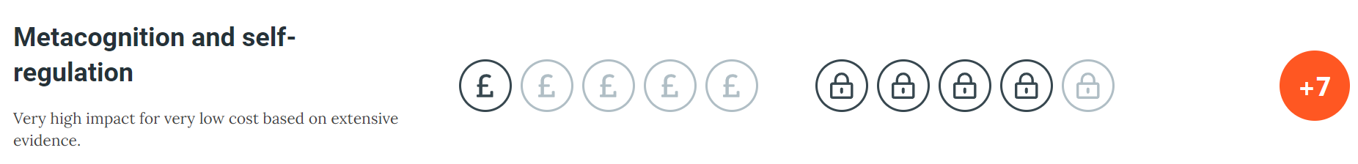  The best available evidence indicates that great teaching is the most important lever schools have to improve pupil attainment. Ensuring every teacher is supported in delivering high-quality teaching is essential to achieving the best outcomes for all pupils, particularly the most disadvantaged among them.  Evidence from the Teaching and Learning Toolkit and EEF-funded projects, focusing on specific themes most relevant to our children, such as feedback, literacy and language strategies and character and life-skills is used to inform our practice and strategy. | 1, 4, 6
Developing collaboration and other key skills and characteristics of learning have a clear impact on pupil attainment:  - CPD in Kagan strategies  - Development of Kagan strategies and skills in all classes | 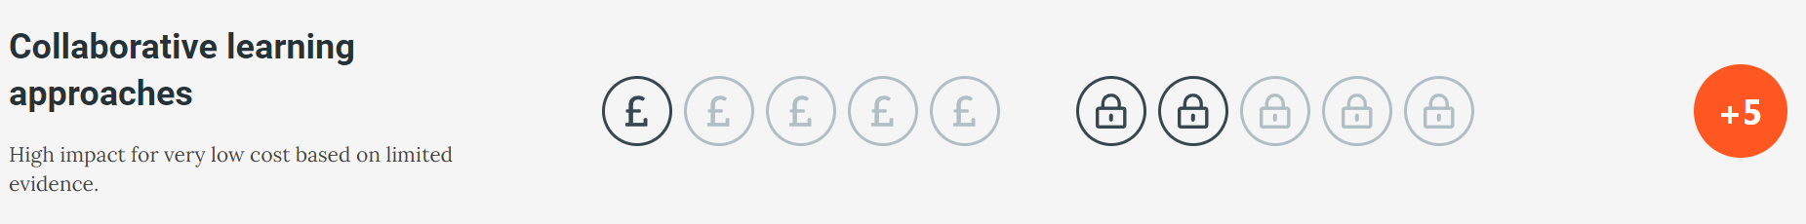  The EEF toolkit shows that The impact of collaborative approaches on learning is consistently positive.  Effective collaborative learning requires much more than just sitting pupils together and asking them to work in pairs or group; structured approaches with well-designed tasks lead to the greatest learning gains.  We therefore directly teach collaboration and peer tutoring/feedback across the curriculum. We maximise learning by using groups of 4 as the ideal | 1, 3, 4, 5, 6

Targeted academic support (for example, tutoring, one-to-one support, structured interventions)
Budgeted cost: £ 42,000
Activity | Evidence that supports this approach | Challenge number(s) addressed
When a pupil needs support in addition to quality first teaching, structured interventions will be put in place. This includes:  • Small group tuition for targeted pupils in English and maths, and, where necessary, one-to-one support.  • High quality and in-depth pupil progress meetings will take place termly to ensure that all pupil premium pupils, who will benefit from 1:1 or small group tuition, are identified and support is quickly put in place.  • Early identification is key. Children will be monitored as soon as they join school.  • Speech and language intervention will be prioritised in EY/KS1.  Third Space maths tuition 1:1 to fill gaps in learning personalised to each child | 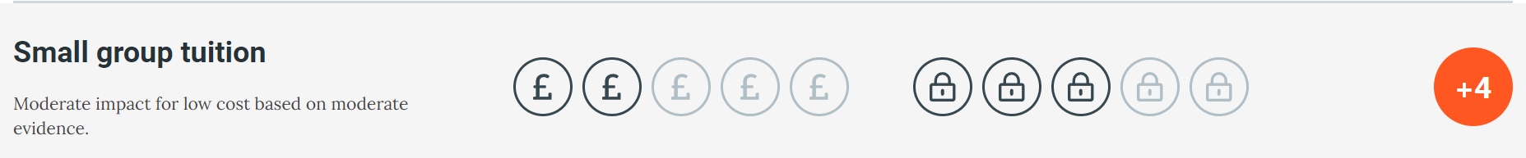  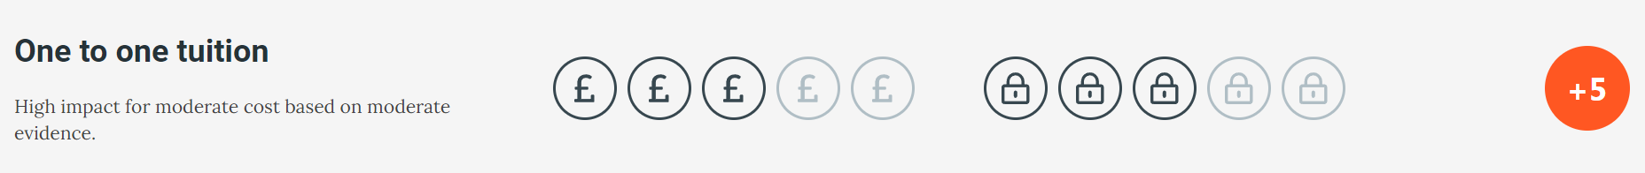  “Considering how classroom teachers and teaching assistants can provide targeted academic support, including how to link structured one-to-one or small group intervention to classroom teaching, is likely to be a key component of an effective Pupil Premium strategy.” EEF  Specific and focused academic interventions are shown to have impact on pupil progress when they are based on data, teacher knowledge and are time limited and evaluated regularly. | 1, 5, 6,
The social and emotional needs of our pupils, along with the impact of trauma can mean that our children are not always ready or in a place to learn effectively:  • Social and emotional interventions and family support interventions, which are used in-conjunction with other interventions.  • Family Support Worker to provide ELSA and make referrals to the mental health team  - Nurture provision for pupils finding the classroom challenging based upon needs of the group and Boxall profiling  - Provision of Art Play sessions  - CPD in ACEs and trauma informed approaches within the classroom | In addition to academic intervention social and emotional interventions have an identifiable and have valuable impact on attitudes to learning and social relationships in school. EEF evidence shows that they also have an average overall impact of four months' additional progress on attainment, and are used in-conjunction with other interventions.  Social and emotional learning interventions seek to improve pupils’ decision-making skills, interaction with others and their self-management of emotions, rather than focusing directly on the academic or cognitive elements of learning. | 2, 3, 5
Early communication and language difficulties can impact our children’s academic progress and ability to communicate their learning:  Specialist speech and language TA to provide interventions  CPD in phonics for all staff and monitoring by EYFS lead  Welkon screening of all EYFS pupils to identify additional support needed  Phonics groups run at the same time so they can be tailored to stages of learning | 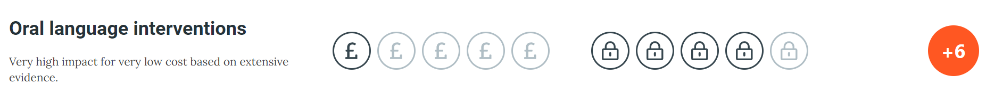  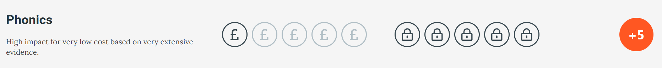  Communication and language approaches emphasise the importance of spoken language and verbal interaction for young children. They are based on the idea that children’s language development benefits from approaches that explicitly support communication through talking, verbal expression, modelling language and reasoning.  Early literacy approaches have been consistently found to have a positive effect on early learning outcomes. The early literacy approaches evaluated to date led to an average impact of four additional months’ progress, with the most effective approaches improving learning by as much as six months. | 1, 4, 6

Wider strategies (for example, related to attendance, behaviour, wellbeing)
Budgeted cost: £ 28,790
Activity | Evidence that supports this approach | Challenge number(s) addressed
Families worker, WEP attendance officer and admin alongside Senior Leaders target children who are regularly late, absent or persistently absent through phone calls, home visits, parent meetings and Team Around The Family. Families supported in overcoming barriers to attendance and signposted to external support if required.  DSL support sessions each half term to discuss best practice and approaches. | 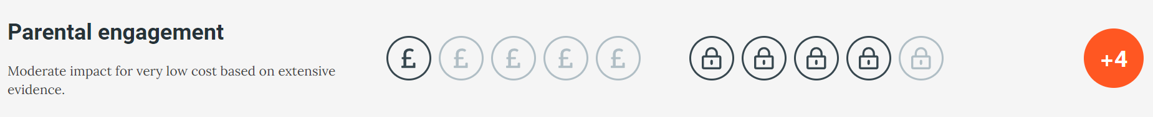  More intensive programmes for families in crisis is a strategy which can significantly impact pupil attainment over time and improve attendance.  Improvements in attendance can have long-term impacts on attainment and social and behavioural outcomes. | 2, 3
Participation in the arts supports our children’s wider learning and development:  STEAM curriculum to promote art and the creative arts  Musical instrument tuition for all Y1-6 pupils  Access to a range of arts activities with specialist providers  Links between creative arts and reading | 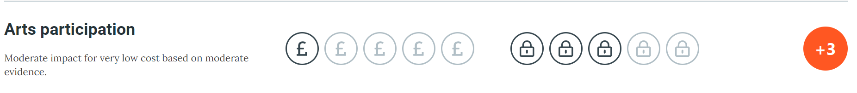  Arts participation is defined as involvement in artistic and creative activities, such as dance, drama, music, painting, or sculpture. It can occur either as part of the curriculum or as extra-curricular activity. Arts-based approaches may be used in other areas of the curriculum, such as the use of drama to develop engagement and oral language before a writing task. EEF | 1, 3, 4, 5, 6
Developing a behaviour culture within school ensures children are ready and able to learn within a safe environment  Development of behaviour policy  Rewards systems to encourage positive behaviour  Behaviour interventions  Use of restoration as a basis for all behaviour support | 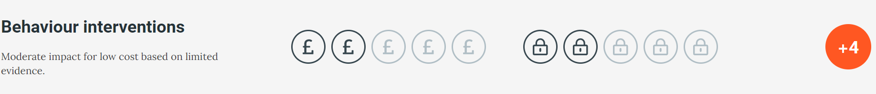  Both targeted interventions and universal approaches have positive overall effects (+ 4 months). Schools should consider the appropriate combination of behaviour approaches to reduce overall disruption and provide tailored support where required.  There is evidence across a range of different interventions with highest impacts for approaches that focus on self-management or role-play and rehearsal. EEF | 2, 3, 5

Total budgeted cost: £ £89, 057

Part B: Review of the previous academic year

Outcomes for disadvantaged pupils
We have analysed the performance of our school’s disadvantaged pupils during the 2021/22 academic year using key stage 1 and 2 performance data, phonics check results and our own internal assessments.
DfE has shared our school’s 2022 performance data with us, to help us better understand the impact of the pandemic on our pupils and how this varies between different groups of pupils.
COVID-19 had a significant impact on the education system and this disruption affected schools and pupils differently, and because of this, it is more difficult to interpret why the results are as they are using the data alone. To help us gauge the performance of our disadvantaged pupils, we compared our results to those for disadvantaged and non-disadvantaged pupils at a national and regional level (although these comparisons are to be considered with caution given the caveats stated above).
Data from tests and assessments suggest that, despite some strong individual performances, the attainment of the school’s disadvantaged pupils is below that of non-disadvantaged pupils. This is inline with the National Figures However, progress was in line with other pupils.
Absence among disadvantaged pupils was higher than their peers in 2021/22. We recognise this gap is too large which is why raising the attendance of our disadvantaged pupils is a focus of our current plan.
Our observations, data tracking and assessments demonstrated that pupil behaviour is having an impact on attainment and progress. Significant numbers of our disadvantaged children display the impact of ACEs, trauma and attachment issues. They are not all ready to learn and are not used to having boundaries in place making it difficult for them to engage in the classroom environment productively.
Summary: Evidence gathered through the school’s self-evaluation strategy has shown that the intervention strategies have begun to be successful across the school overall and will continue to be targets for the next academic year to ensure all strategies are well embedded. Additional targets will added to support learners. With the lifting of Covid restrictions and the removal of bubbles there will be wider opportunities to develop the plan.

Externally provided programmes
Please include the names of any non-DfE programmes that you used your pupil premium (or recovery premium) to fund in the previous academic year.
Programme | Provider

Service pupil premium funding (optional)
For schools that receive this funding, you may wish to provide the following information: How our service pupil premium allocation was spent last academic year
The impact of that spending on service pupil premium eligible pupils

Further information (optional)
Our pupil premium strategy will be supplemented by additional activity that is not being funded by pupil premium or recovery premium. That will include:
• embedding more effective practice around feedback. EEF evidence demonstrates this has significant benefits for pupils, particularly disadvantaged pupils
• offering a range of high-quality extracurricular activities to boost wellbeing, behaviour, attendance, and aspiration. Activities will focus on building life skills such as confidence, resilience, and socialising. Disadvantaged pupils will be encouraged and supported to participate.

