

**Good attendance matters**

Attending regularly is the key to children being successful at St Chad’s and will prepare them for the routine of the world of work. By making sure your child attends school you are giving them the opportunity to:

* Make friends, socialise and have fun on the playground
* Learn many new things and develop their skills in our exciting lessons
* Increase their confidence, self-esteem and resilience
* Help them achieve their potential and be successful
* Join fun exciting activities, trips and events

**The Impact**

Children at St Chad’s do brilliantly in their KS2 Sats and perform above the national average. We know that children at St Chad’s who have good attendance are significantly more likely to meet the expected standard at Y6 than those who don’t. Children who miss school have gaps in their learning and are unable to meet the challenge of the end of year assessments.

If children do not attend school regularly, they may:

• struggle to keep up with schoolwork

• have few opportunities to catch up on missed learning

• miss out on the social side of school life

• miss opportunities to make and keep friendships

**What if my child is ill?**

The NHS has great advice on attendance and illness, you can your child’s illness here: <https://www.nhs.uk/live-well/is-my-child-too-ill-for-school/>

**What happens if my child is absent?**

We will notify you if your child’s attendance level is a concern and work with you and your child to improve it. We may meet with you to agree an Attendance Contract. If attendance continues to require improvement, then we will look to initiate an Attendance Improvement Meeting (AIM). The AIM is the beginning of the legal process. It is important that you engage with the process and work with the support provided to meet the agreed targets. These targets will be reviewed, and progress evaluated at a review meeting. If satisfactory progress is made, then targets will be considered met or adjusted until attendance is satisfactory. If progress is not made, then you will be referred to the LA for legal intervention. You risk being issued with a Notice to Improve, Penalty Notice or being prosecuted in court.

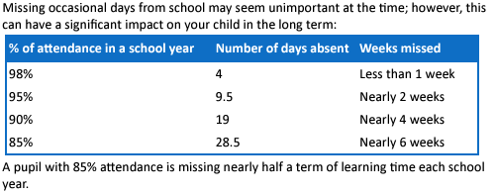

**What is the difference between authorised and unauthorised absence?**

When you register your child at school, you have a legal duty to ensure your child attends that school regularly.

This means that your child must attend every day that the school is open, unless:

* Your child is too ill to attend that day.
* You have asked in advance and been given permission by the school for your child to be absent on that day due to exceptional circumstances.
* Your child cannot attend school on that day because it is a day you are taking part in religious observance

**Wherever possible, you should make routine appointments e.g., dental check-ups during the school holidays or after school hours.**

These are all authorised absences. If your child is regularly too ill to attend school, we will work through the medical needs process to support them.

Absences outside of these reasons are unauthorised.

**Absence and the Law**

As a parent you are committing an offence if you fail to ensure that your child attends school regularly. Details of parents with children who have unauthorised absence or who have taken unauthorised leave will transfer to Cheshire West and Cheshire Council, who may issue a fixed penalty notice or consider legal action.

**What happens if I go to court?**

* Parents can be fined up to £2,500 or imprisoned for failing to ensure that their child attends school regularly.
* Magistrates can impose a Parenting Order, which means that parents must attend a counselling and guidance program, usually a parenting class.

**Being late for school**

When your child is late it is disruptive to your child, their class and their teacher. Late lunch orders have to made, your child has to be helped to catch up on what they have missed, and the lesson is interrupted. The start of the day at St Chad’s focuses on key number skills and children who miss this do not achieve well in maths. We also run interventions at this time, so children who need support and are late miss out on their extra help.

At St Chad’s the register closes at 9.15am, if you arrive after this time, you will **receive an unauthorised absence for the whole morning session**.

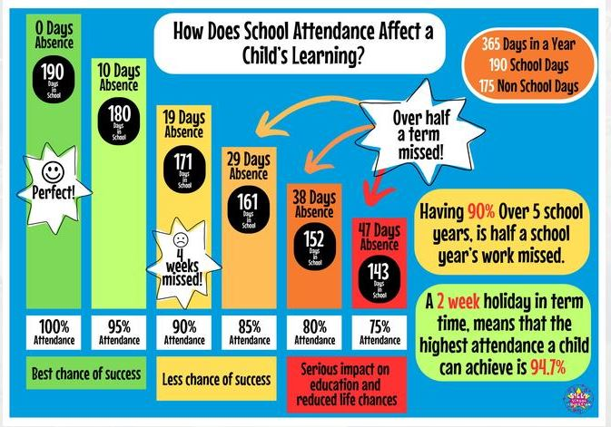

**Holidays**

Holidays in term time cannot be authorised by Headteachers under the new guidance.

